Running the provided ASR example in Docker Desktop
- Open Docker Desktop: and ensure it is running correctly.
  - Check the docker-installation.docx file for instructions
- Navigate to Your Project Folder: Open a terminal (Command Prompt, PowerShell, or any terminal you prefer) and navigate to the speechToText folder.
  - You get this folder when speechToTextandsamples.zip is extracted
- Build the Docker Image: run the following in a terminal you just opened
docker build -t speech-to-text .
This command will build a Docker image named speech-to-text using the Dockerfile in your project folder.
- -t gives a name to the image
- . means the build will happen inside this same directory
- Note: Build most likely takes 10+ minutes thus it installs many things into container and downloads the AI models
- Next builds will be a lot faster unless run with --no-cache option
- Run the Docker Container:
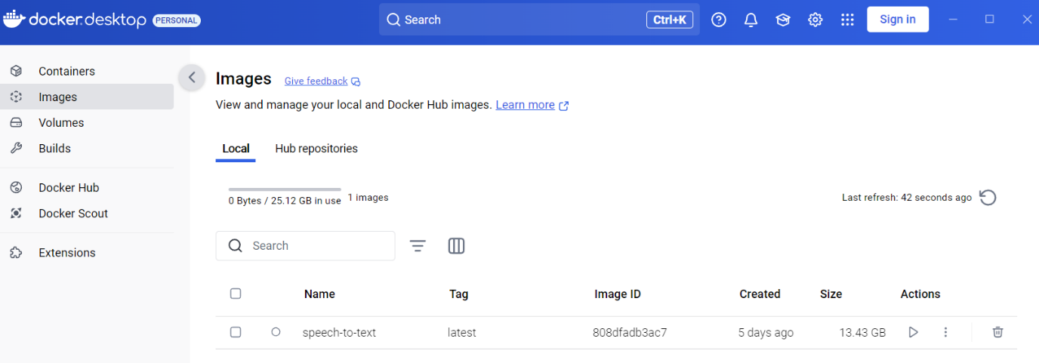
  - Once the image is built, go to the "Images" tab (Docker desktop left menu).
  - Click the "Run" button next to your speech-to-text image under Actions.
    - Note! If you intend to use GPU(s) you will need to launch via command line (terminal) and include the gpus tag.
docker run --name ASRdemo -d --gpus=all -p 8004:8004 speech-to-text
    - After this you can jump to step 5
  - In the "Run a new Container" dialog, open optional settings and alter the configurations:
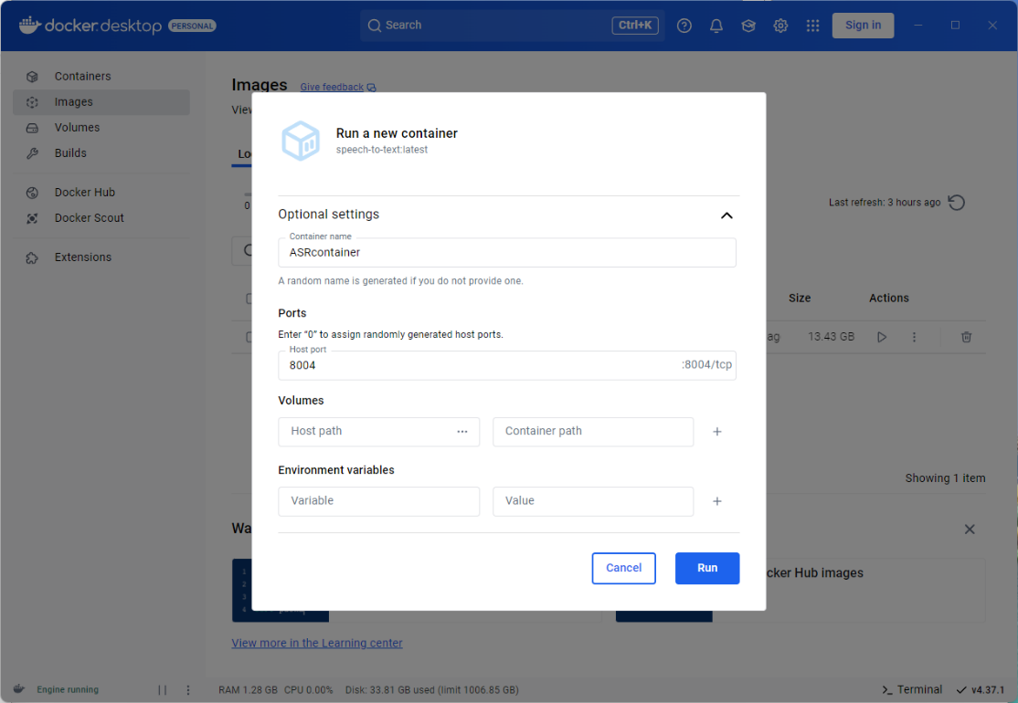
    - Name: Give your container a name (optional).
    - Host port: Map a host port to an exposed container port (dockerfile). Use what ever port you want. Right side example uses the same 8004 as the exposed port.
    - Volumes and Environment Variables: No need to fill
  - Click "Run".
  - You are automatically moved into containers tab and you should see the logs for the running container
    - After you see text “Device set to use cpu” or “Device set to use cuda” move forward
- Access Your Application: Open a web browser and go to http://localhost:8004 (or the port number you defined) to access your application.
  - Starting the app takes some seconds, so if you are too fast you might see page not available info. Just refresh the page few times and you should be fine.

